<https://aws.amazon.com/compliance/eu-data-protection/?trk=eudp_Em3_mar&mkt_tok=MTEyLVRaTS03NjYAAAGDSpLiTGGV41IaJ0had6_01nCZhsACHMh3PP7an1jz2Pey93ECEp5lT9H5cvCM1_k4s_YTs-oDrvgwLeCDOClbCYLcT4EOIVAnHk7IirmqwaBDNGAhxA#Spotlight_on_EU_data_transfer_requirements>





<https://youtu.be/fyhmOaqYsGw>

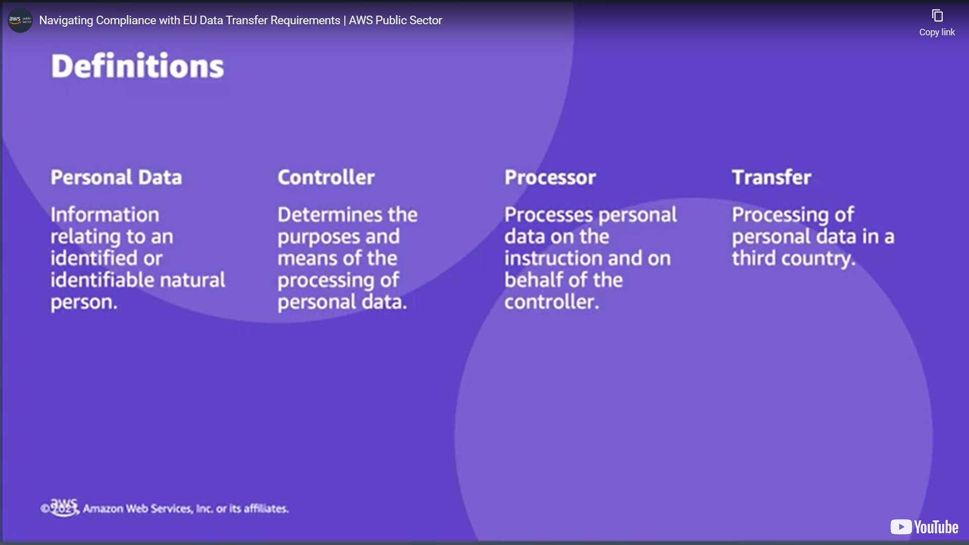

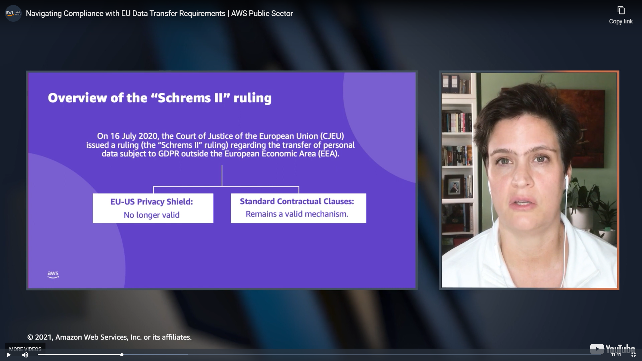

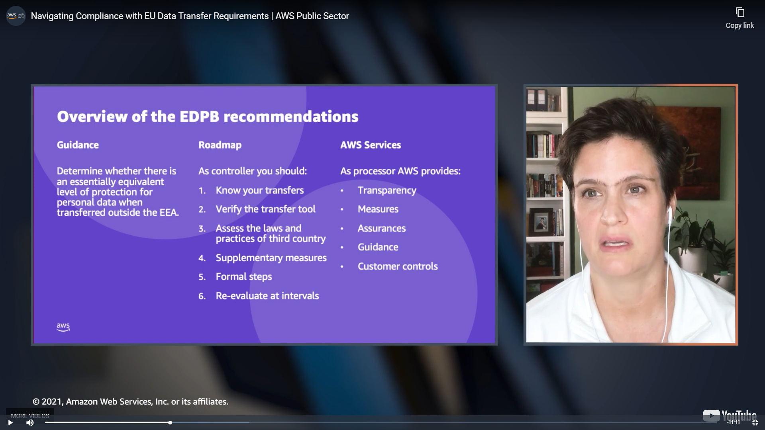



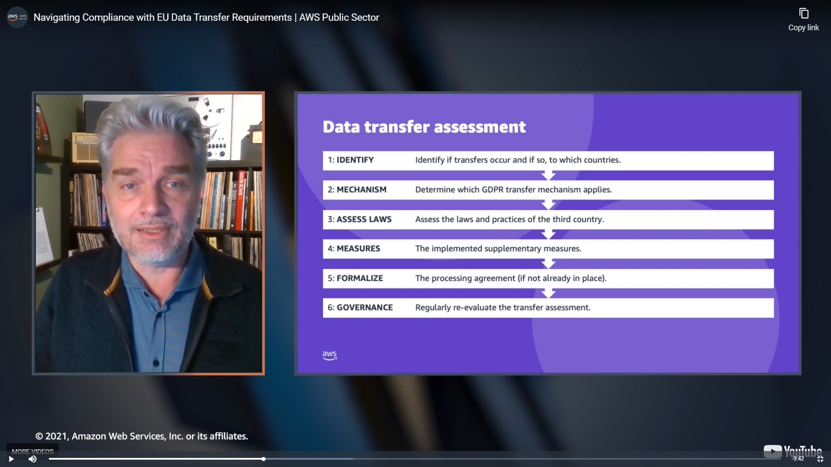

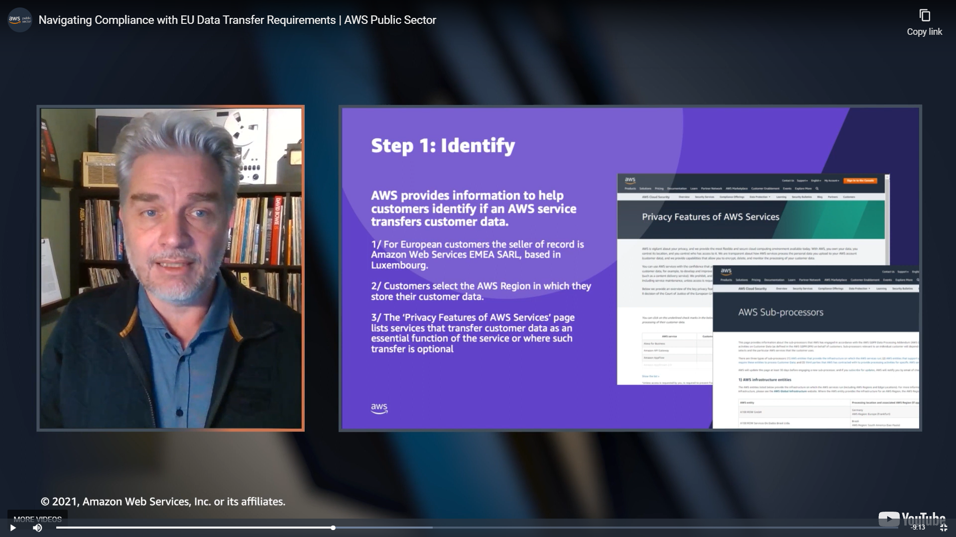

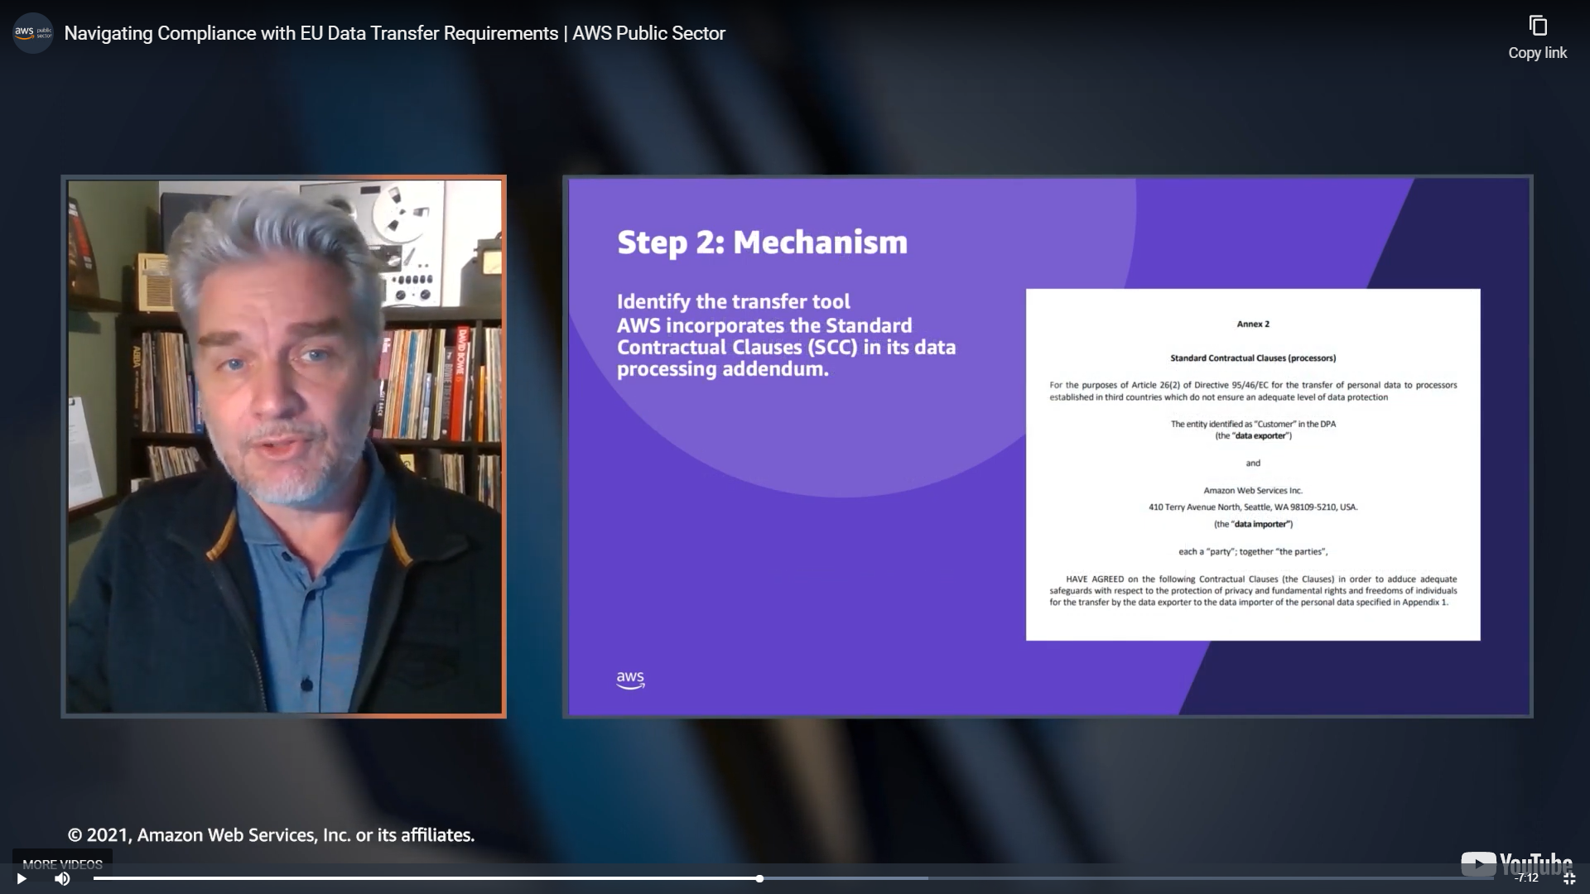

SCC = STANDARD CONTRACTUAL CLAUSES (SCC), TO VALIDATE TRANSFERS

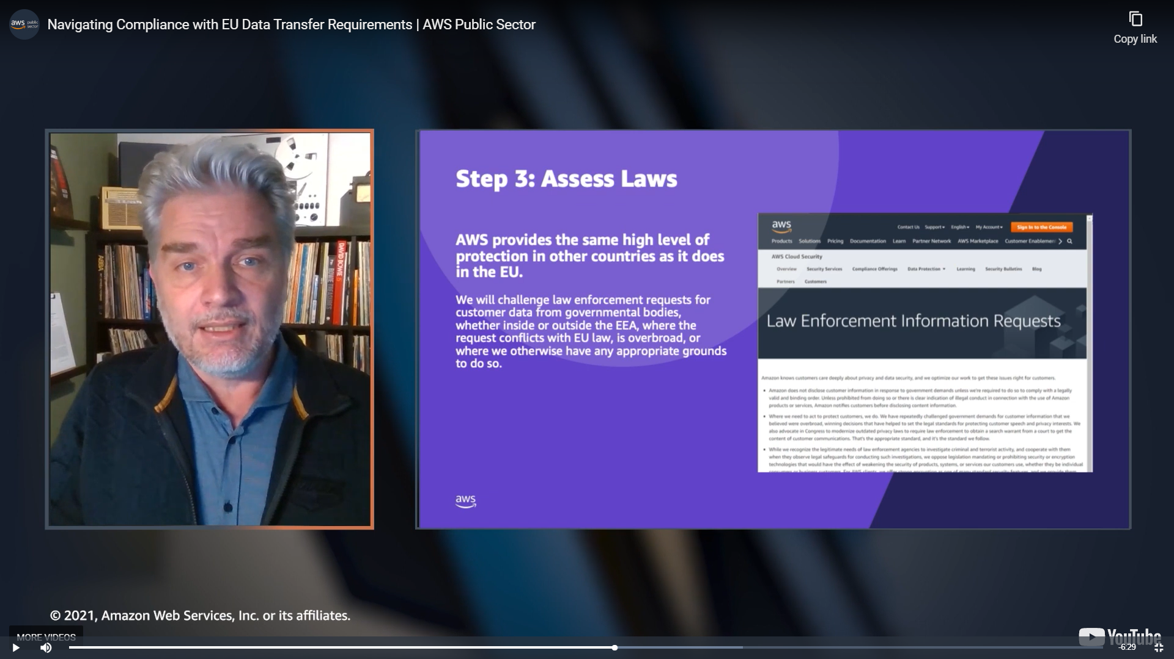

Content can be encrypted, in transfer or in rest.

